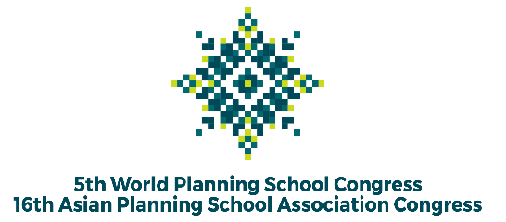

The 5th WPSC and 16th APSA Congress in 2022
“Planning a Global Village: Inclusion, Innovation, and Disruption”

Abstract

Selected Track *)

1. | Title
Abstract
(200 - 400 words)
Explain background and purpose, methods, results, and conclusion.

 | Author (s), the first is the presenter.
 | Affiliation
 | Email Contact

*) Tracklist:
- Track 1: Urban, Peri-Urban, and Metropolitan Development
- Track 2: Informality, Inclusion, and Participation
- Track 3: Heritage, Culture, and Identity
- Track 4: Disaster, Risk, and Resilience
- Track 5: Environment, Climate, and Health
- Track 6: ICT, Knowledge, and Innovation
- Track 7: Spatial Analysis, Methods, and Modelling
- Track 8: Governance and Politics
- Track 9: Infrastructure, Transport, and Mobility
- Track 10: Rural, Regional, and Small Island Development
- Track 11: Planning History, Theory, and Practice
- Track 12: Planning Education and Pedagogy
- Track 13: Land, Housing, and Settlement

