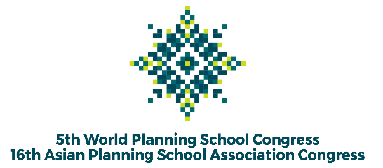

The 5th WPSC and 16th APSA Congress in 2022
“Planning a Global Village: Inclusion, Innovation, and Disruption”

Session Proposal

Selected Track *)

Title of Session

Name of Chair(s)

Email & Contact Details of Chair(s) /Organizer

Organizer Affiliation
Session’s abstract
(300 words)
Type of session  (Tick the most suitable with your session) |  | - Paper presentation and discussion  - Poster presentation and discussion  - Panel  - Roundtable forum  - Debate  - Author meets critiques  - Workshop
List of potential contributors |  | Please raise 3 to 5 proposed speakers. Once your session has been accepted, all the speakers will be asked to register and submit abstracts for their talk.
1. | Title
 | Author (s), the first is the presenter.
 | Affiliation
 | Email Contact
 | Abstract (for “Paper presentation” session type - 300 words)
2. | Title
 | Author (s), the first is the presenter.
 | Affiliation
 | Email Contact
 | Abstract (for “Paper presentation” session type - 300 words)
3. | Title
 | Author (s), the first is the presenter.
 | Affiliation
 | Email Contact
 | Abstract (for “Paper presentation” session type - 300 words)
4. | Title
 | Author (s), the first is the presenter.
 | Affiliation
 | Email Contact
 | Abstract (for “Paper presentation” session type - 300 words)
5. | Title
 | Author (s), the first is the presenter.
 | Affiliation
 | Email Contact
 | Abstract (for “Paper presentation” session type - 300 words)
Website URL (if any)

*) Tracklist:
- Track 1: Urban, Peri-Urban, and Metropolitan Development
- Track 2: Informality, Inclusion, and Participation
- Track 3: Heritage, Culture, and Identity
- Track 4: Disaster, Risk, and Resilience
- Track 5: Environment, Climate, and Health
- Track 6: ICT, Knowledge, and Innovation
- Track 7: Spatial Analysis, Methods, and Modelling
- Track 8: Governance and Politics
- Track 9: Infrastructure, Transport, and Mobility
- Track 10: Rural, Regional, and Small Island Development
- Track 11: Planning History, Theory, and Practice
- Track 12: Planning Education and Pedagogy
- Track 13: Land, Housing, and Settlement

