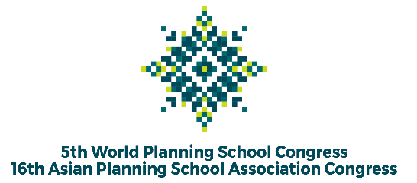

The 5th WPSC and 16th APSA Congress in 2022
“Planning a Global Village: Inclusion, Innovation, and Disruption”

Pre-Congress Program
Abstract for Ph.D. Colloquium

Ph.D. Research Title

Name of Ph.D. Student

Email

Affiliation
(Department, University, Country)
Research abstract
(200-250 words)
Research stage  (Tick the most suitable with your current stage, you may choose more than 1) |  | - Proposal development  - Data collection and analysis  - Writing and finalizing the dissertation  - Publication
List of supervisory teams |  | Please complete the data of your supervisory team. The committee may invite them to join the colloquium as discussants.
1. | Position | Supervisor / Co-supervisor 1 / Co-supervisor 2
 | Name (with title)
 | Affiliation
 | Email Contact
2. | Position | Supervisor / Co-supervisor 1 / Co-supervisor 2
 | Name (with title)
 | Affiliation
 | Email Contact
3. | Position | Supervisor / Co-supervisor 1 / Co-supervisor 2
 | Name (with title)
 | Affiliation
 | Email Contact

